
D a f f o d i l I n t e r n a t i o n a l U n i v e r s i t y

Department of software engineering
Spring - 2015
Course code: SWE231
Course Title: Software Engineering project-1

EMPLOYEE MANAGEMANT SYSTEM

Submitted by
Mohammad Riham Hossain
ID: 142-35-659

Avijit Das
ID: 142-35-668

Submitted to

Kaushik Sarker
Lecturer
Department Of Software Engineering
Daffodil International University

Board of Examiners

__________________________________
Assoc. Prof. DR. TOUHID BHUIYAN
Head of the Department
Department of SWE
Faculty of Science & Information Technology
Daffodil International University

________________________
Kaushik Sarker
Lecturer
Department of SWE
Faculty of Science & Information Technology
Daffodil International University

DECLARATION

We hereby declare that, this project has been done by us under the supervision of Name, Designation, and Department of SWE Daffodil International University. We also declare that neither this project nor any part of this project has been submitted elsewhere for award of any degree or diploma.

Supervised by:
_______________________
Kaushik Sarker
Lecturer
Department of SWE
Daffodil International University

Submitted by:
_____________________
Mohammad Riham Hossain
ID: 142-35-659
Department of SWE
Daffodil International University

____________________
Avijit das
ID: 142-35-668
Department of SWE
Daffodil International University

ACKNOWLEDGEMENT

First, we express our heartiest thanks and gratefulness to almighty Allah for His divine blessing makes us possible to complete this project successfully.
We fell grateful to and wise our profound our indebtedness to Kaushik Sarker Lecturer, Department of software Engineering, Daffodil International University, Dhaka. For his deep knowledge and keen interest in the field of our project, named “Employee Management System” with C programming influenced us to carry out project. His endless patience, scholarly guidance, continual encouragement, consent and energetic supervision, constructive criticism, valuable advice, reading many inferior draft and correcting them at all stage have made it possible to complete this project.
We would like to express our heartiest gratitude to Head, Department of SWE for his kind help to finish our project and also to other faculty members and the staffs of SWE department of Daffodil International University.
Finally, we must acknowledge with due respect the constant support and patients of our parents.

“E m p l o y e e M a n a g e m e n t S y s t e m”

Page – 1 of 23

Employee Management System

No. | Content Page
1. | Introduction……………………………………………………................. 3
2. | Literature review …………………………………………………………… 3
3. | Existing System………...…………………………………………............ 4
4. | Project goal………………………………………................................ 4
5. | Software Requirement Specification………………………………. 5  5.1 Functional Requirement………………………………………….. 5  5.2 Non-Functional Requirement………………………………….. 5  5.3 Use Case………………………………………………………............ 6  5.4 Operating Environment…………………………………………… 7
6.  7.  8. | Methodology………………………………………………………............. 7  Implementation………………………………………………………………. 7  7.1 Project Implementation phase involves…………………… 7  7.2 Project implementation plan (PIP) ………………………….. 7  7.3 Project implementation plan includes ……………………. 8  Testing……………………………………………………………………………. 8  8.1 White box testing……………………………………………………. 8  8.2 Black box testing……………………………………………………… 8  8.3 Project testing by our self………………………………………… 8  8.4 Project testing by users……………………………………………. 8
9. | Result and discussion……………………………………………………… 9  9.1 Lacking of our System……………………………………………… 9  9.2 Future work……………………………………………………………. 9  9.3 Strong point of this project…………………………………….. 9  9.4 Weak point of this project………………………………………. 10
10. Conclusion ………………………………………………………………………….. 11
11. Appendix ………………………………………………………………………….. 12
11.1 Using process of the project……………………………………….. 12
11.2 Screen Shots ……………………………………………………… 13-16
11.3 Pseudo code………………………………………………………. 17-22
12. Reference…………………………………………………………………………….. 22

Page –2 of 23

1. Introduction:
Employees are the backbone of any company, management of employee performance plays a major role in deciding the success of the organization. The workshop has a problem in management of employee performance. The current system running in the workshop is paper based. That is the workshop is still using cabinet files to store records of stock and employee information. Useful data is scattered all over the place. he "EMPLOYEE MANAGEMENT SYSTEM " has been developed to override the problems prevailing in the practicing manual system. This software is supported to eliminate and in some cases reduce the hardships faced by this existing system. Moreover this system is designed for the particular need of the company to carry out operations in a smooth and effective manner.
The application is reduced as much as possible to avoid errors while entering the data. It also provides error message while entering invalid data. No formal knowledge is needed for the user to use this system. Thus by this all it proves it is user-friendly.

2. Literature review:

“Employee management system”- is an automated computer system, which works on desktop based PCs, easy to use and saves time and energy as well. Both admin and members of Institute can use this by entering their name and data on version 1.0.
To the upgrade version (2.0) we’ll make more automatic system like- by entering only user’s ID it’ll make ready all the necessary information. We think that’ll be more effective and comfortable for both users and admin.
Write down the related work done previously with references.

Page – 3of 23

3. Existing System:

There is a problem with current system, that’s why we made up this, here it is --

- The important and the most significant drawback is that the system is manual. There are errors due to carelessness or oversight that may result in loss to the data and as to the organization. For an organization, time is very important factor.

- The employee information are stored in the Sanchez application which is like a excel sheet. This makes it impossible to search for company information in such a long table manually and to add a new query if the searched query is not available.

4. Project Goal:

In this world of growing technologies everything has been computerized. With large number of work opportunities the Human workforce has increased. Thus there is a need of a system which can handle the data of such a large number of Employees in an organization. This project simplifies the task of maintain records because of its user friendly nature.
- Easy to use
- Tracks up to date work status
- Ability to add employees, easily and flexibly
- Reduces HR daily work, increases productivity
- Employee satisfaction and a significant cost savings.
- Eliminate paper work.

Page – 4 of 23
5. Software Requirement Specification:

When we selected this project we thought about some specific
Software requirement, like as -

- Who will use this system
- Is it their reliable or not?
- Functional & Non- functional requirements
- OS & Operating Environment

5.1 Functional Requirement:

The functional requirements of the system are like below:

- Saving problem = It must have the capacity to save the giving information form the user.
- Login = It must take advance login for the user.
- Logout = It must assure that one employee can’t leave the institute without permission.
- Compiler = Here, we use GNU GCC compiler. And it can work at any executable environment.

5.2 Non – Functional Requirement:

The non-functional requirements are given below:
- Speed =Take a little time to execute the full program.
- Platform compatibility = Can work on any OS (operating environment) like Windows with Code Block, Turbo C etc.
- Usability = for being simple and easy coding it becomes understandable to all especially to the students. They can easily able to use this system and got best feedback.
Page – 5of 23
- Quality = It can be used by any level of users of DIU who needs to book bus ticket from DIU. But this system is mostly preferable for the student and members.
- Update = our system will be updated more in future.
- Efficiency = It can work on any platform and it can be handled easily by anyone.
- Extensibility = we can able to add any features and any more option at any time with our system.
5.3 Use Case:
Here, we’re giving a use case diagram to represent our system on functional requirements……..
Build System
Add New Employee Data
Edit Employee Data
View Employee Record
Remove Employee Data
Show Daily Entries
Login
View all Record
Logout
Developer/Engineer
Admin
Employee

Developer/

Fig 01- Use case diagram of the functional requirement.

Page – 6 of 23

5.4 Operating Environment:
Any operating environment like as Windows, Linux and Mac can execute the system if there is compiler named “GNU GCC”
Here we use WINDOWS operating system.

6. Methodology:
We use these things to implement our project:
- Platform compatibility = Windows
- Compiler = Here, we use GNU GCC compiler
7. Implementation:
Process whereby “project inputs are converted to project outputs”. May be looked at as:
  - Putting in action the activities of the project.
  - Putting into practice what was proposed in the project document (i.e. transforming the project proposal into the actual project.)
  - Management of the project or executing the project intentions.

7.1 Project Implementation phase involves:
- Project activation, and
- Project operation
Project activation
- This means making arrangements to have the project started. It involves coordination and allocation of resources to make project operational.
Project operation
- This is practical management of a project. Here, project inputs are transformed into outputs to achieve immediate objectives.
- This means making arrangements to have the project started. It involves coordination and allocation of resources to make project operational.

7.2 Project implementation plan (PIP)
- If PIP not carried out during the project design process and embodied in the project documents, it is carried out at the project activation stage.
Page – 7 of 23
7.3 Project implementation plan includes:
- What activities can produce expected project outputs?
- What is the sequence of these activities?
- What is the time frame for these activities?
- Project Evaluation and Review Techniques (PERT)
8. Testing:
8.1 White box testing:
- This is a verification technique for software developers use to examine if their code works as expected. We will use this method to detect errors during software (project) development. White box which is also known as clear box helps in optimizing of my code. Using the aspect of unit testing we shall be go through each and every line of code. This makes it easy for us to remove extra lines of code that can bring about hidden errors.

8.2 Black box testing:
- It is also known as functional testing. This technique is used to test the complete system. Black box testing ignores all the whole system components and focuses only on the outputs generated for a particular input. Different data will be used for each function to check if the right output is gotten. This is to check the behavior of the system as per different input data.

8.3 Project testing by our self:
- We (project members) were tested our project many more times for check it was working properly or not. By checking our project we were able to fixed some bugs and set properly cursor position.

8.4 Project testing by users:
- We also tested our project by some general users. They also compile and run program easily. They were very excited after using the software, but sometimes they can’t input in program. Some of them thanks us and some other users told us the software made more efficient in future days.
Page – 8 of 23
9. Results and Discussion:
This program is in Testing. We hope the program executed properly.

9.1 Lacking of our System:
Because of short time and little bit knowledge we couldn’t build up the full-fill system. Our system is till now under developing.
There is also another lacking and that is, if any one gives any negative or symbolic input, it’ll take that. We are trying to solve this problem but unfortunately till now we can’t able to solve it.

9.2 Future Work:
Basically, our system is now under construction and so our first work will be to solve that particular problem about that we talk just before. And after that we will try to develop this application, which we mention above because here we only built the application, which only works as an in putter not auto in putter from ID.
  - Strong point of this project:
- The system is password protected.
- For accessing this system user must be enter correct password.
- When user input the password the system show symbol. So nobody can’t see password.
- Password only enable for data entry option.
- There are different options for data entry.
- Only admin can access the data entry options.
- Only admin can add, remove, show daily entries, search employee record and edit employee record, because this option is password protected.
- See daily time record system and if anyone sees this options then this person must enter his id to log-in and then this person enjoy this options.
- Our system record time, date, month, hour, minute, second for particular employee.
- Our system has log-out options. If anyone log-out must enter his id.
Page – 9 of 23

  - Weak point of this project:

- If user of this system enter wrong password then he cannot delete it by using back space.
- When admin use data entry option and input data then gender option can’t accept the input and after giving input at the place of work experience then next input collector option gender has automatically skipped so admin can’t input gender. But this problem sometimes automatically solved. This bug makes us fool.
- There is a options into data entry named record time for all employee sometimes it works properly means that it show employee id and time which has been record but sometimes this system does not work properly.
- When admin enter data entry option and if he wants to back main menu and then if admin press 6 then it can’t work so admin can’t go back main menu.
- If admin enter in the employee time record system and press 1 for time record for particular employee and enter employee id to search (which id is already saved to the system) then it can’t show the desired result.
- When press enter search employee record and enter id or name then it can’t show proper result, but sometimes this options works properly.
- Sometimes remove employee id and edit options could not work.

Page – 10 of 23

10. Conclusion:
In this report, an information system’s development has been presented. It was emphasized on the basic steps, consequently taken during the project’s development course as a particular attention was turned to the basic operative functions performed upon the data into the database.
The report’s content comprises the whole task solution, starting from the programming environments have been selected, going through the database, the application’s analyze and construction, and finishing with the code-implementation and test-samples, shown separately in Appendix chapters.
As a future work, some additional stuff could be implemented and integrated into the application code making it much more reliable and flexible; especially what concerns a pay-roll module, for instance. Apparently, the role of such systems is basic and essential within each company that wants to keep a really good control and record concerning its personnel data, functionality and performance on all levels in its structure. Every organization, in nowadays, has the necessity of managing its staff on a really good level as the staff has definitely the greatest merit of building up a company as such as it is.
The well managed staff means giving the appropriate financial awareness and all kind of benefits as such as they have been deserved. That’s why the development of such systems is not just a programming business – a lot of people are ordinarily involved in such projects and one of the basic requirements is the reliability of the system, especially what concerns the storage of data and all of the operations that will be performed upon it.

Page – 11 of 23

11. Appendix

An appendix or appendices are usually the last pages in a document/project. It contains things that we did not have space for in the main part of our project.
Examples of information that could be included in an appendix include
Figures/tables/charts/graphs of results, statistics, questionnaires, transcripts of Interviews, pictures, lengthy derivations of equations, maps, drawings, letters,
Specification or data sheets, computer program information. The information included in the appendix must bear directly relate to the report's purpose.

So appendixes of our project are shown in below:

11.1 Using process of the project:

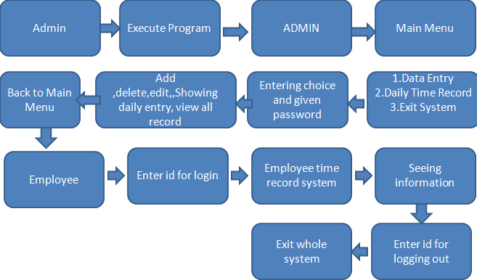

Page – 12 of 23
11.2 Screenshots of our project:

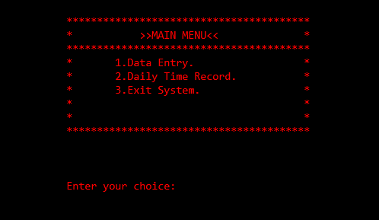

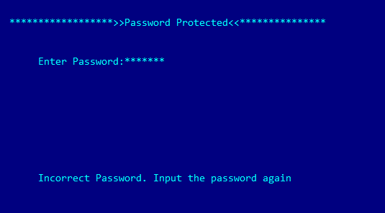

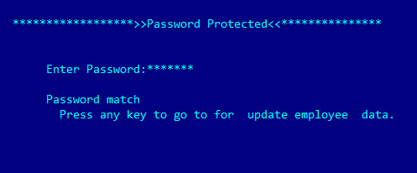

Page – 13 of 23

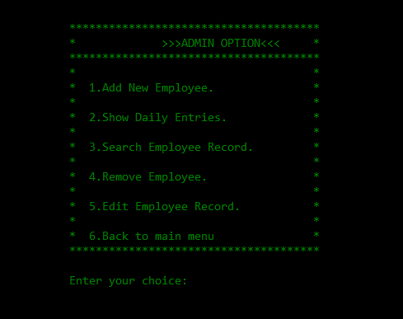
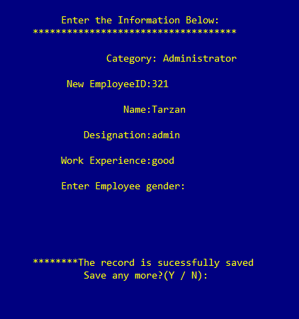

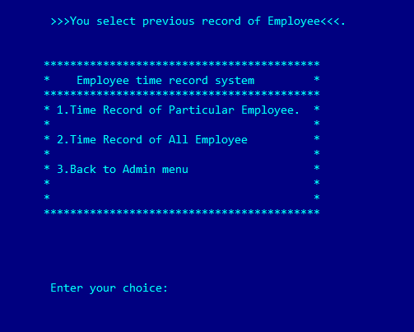

Page – 14 of 23
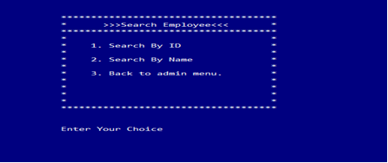
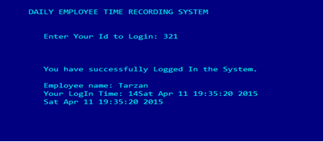
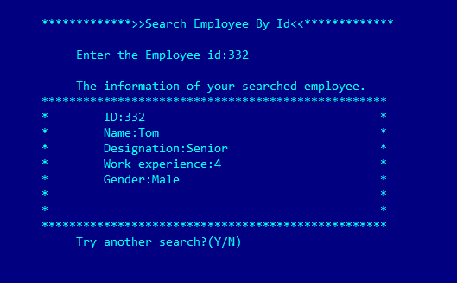
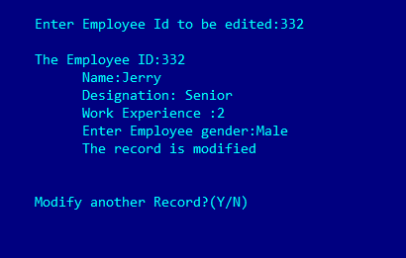
Page – 15 of 23
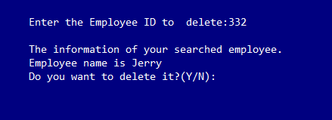
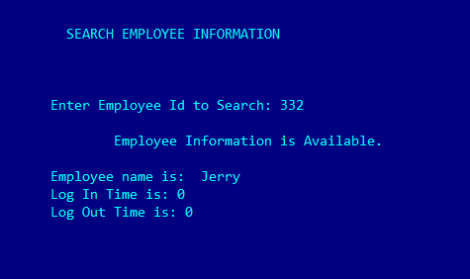

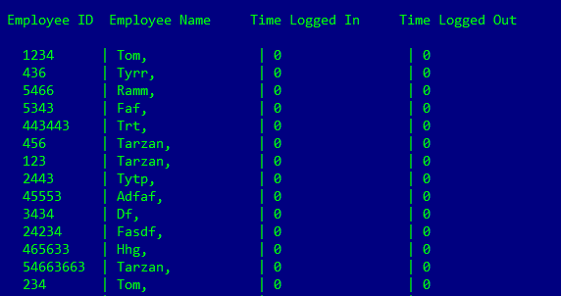

Page – 16 of 23

  - Pseudo code:
For time recording:
Void timerecord ()
{
Clear screen
Set color
Set cursor point
Print symbol
Print employee time record system
Set cursor point
Print symbol
Print time record of particular employee
Set cursor point
Print symbol
Print time record of all employees
Set cursor point
Print symbol
Print back to admin menu
Set cursor point
Print enter your choice
Char input = getchar ()
Switch case (input)
Case 1:
Page – 17 of 23
Particularemployeesearch ()
Break
Case 2
searchalltmr ()
Break
Case 3
adoption ()
Break
Default
Goto inputoptions
}
For searching employee
Void searchemployees ()
{
Declare int type variable i
Clear screen
Set color
Char findemployee=int type value
Set cursor point
Print symbol
Declare int type variable employeeId
Print search employee
Set cursor point
Print symbol
Page – 18 of 23
Repetition
for (i=int value ;<=int value;i++)
{
Print symbol
}
Set cursor point
for(i=int value;<=int value;i++)
{
Print symbol
}
Set cursor point
Print search by id
Set cursor point
Print symbol
Print search by name
Set cursor point
Print symbol
Print back to admin menu
Set cursor point
Print symbol
Print enter choice
Fileopen (“filename”,rb)
Switch (input)
Page – 19 of 23
Case 1
Sleep the system
Clear screen
Set color
Print search employee by id
Enter employee id
Input id
While (fileread,(&employee, size of(file),1,fileopen)==1)
If employee id found
{
Print the information of your searched employee
Print employee id
Print employee name
Print employee designation
Print employee wage
Print employee gender
}
If not found
{
No record found
}
Print try another search
}
Page – 20 of 23
Editing employee id:
Void editemployeeid ()
{
Clear screen
Set color
Print type employee id to edit
Fileopen (“filename”,rb+)
while (fread (&employee, sizeof (employee), 1, fp)==1)
{
If employee id is found
{
Scan name
Scan designation
Scan work experience
Scan gender
Print employee information has been deleting successfully
}
If employee id is not found
{
Print no record found. Try again
}
}
}
Page – 21 of 23

Removing employee
Void removeemployee ()
{
Clear screen
Set color
Declare a int variable
Print type employee id to delete
Fileopen (“filename”, rb+)
while (fread (&employee, sizeof (employee), 1,fp)==1)
{
If employee id is found
{
Print employee information has been deleting successfully
}
If employee id is not found
{
Print no record found. Try again
}
}
}

Page –22 of 23

12. Reference:
[1] E Balagurusamy, C. R. (2011-2012). Programming in ANSI C. “User-defined Functions; File management in C”.
[2] Md. Islamil Jobiullah, C. R. (Aug’2000). Shohoj Vashai C Programming. “Chapter 7: Functions; Chapter 10: Use of Pointer”.
[3] Standard functions, Retrieved on October’13. Available at https://cs50.harvard.edu/resources/cppreference.com/stdother/index.html
[3] Basics of C, Retrieved on November’13. Available at http://www.howstuffworks.com/c.htm
[4] Closing the file in C, Retrieved on October’13. Available at http://www.learnconline.com/
[5] Function Pointer, Retrieved on October’13. Available at http://www.learn-c.org/
[6] Opening file in C, Retrieved on November’13. Available at http://www.programmingsimplified.com/c-program-read-file
[7] Copy file in C, Retrieved on November’13. Available at http://www.programmingsimplified.com/c-program-copy-file
[8] Login system in C, Retrieved on November’13. Available at http://forums.speedguide.net/archive/index.php/t-60150.html
[9] Use of gotoxy function in C. Retrieved on November’13. Available at http://wiki.answers.com/Q/What_is_gotoxy?#slide=1
[10] Use of #include <windows.h> header in C. Retrieved on November’13. Available at http://en.wikipedia.org/wiki/Windows.h

Page – 23 of 23

